**Quartz Crystal Encrusted Circular Mirror by Marjorie Skouras, White, 42"**

**Price: $3785**

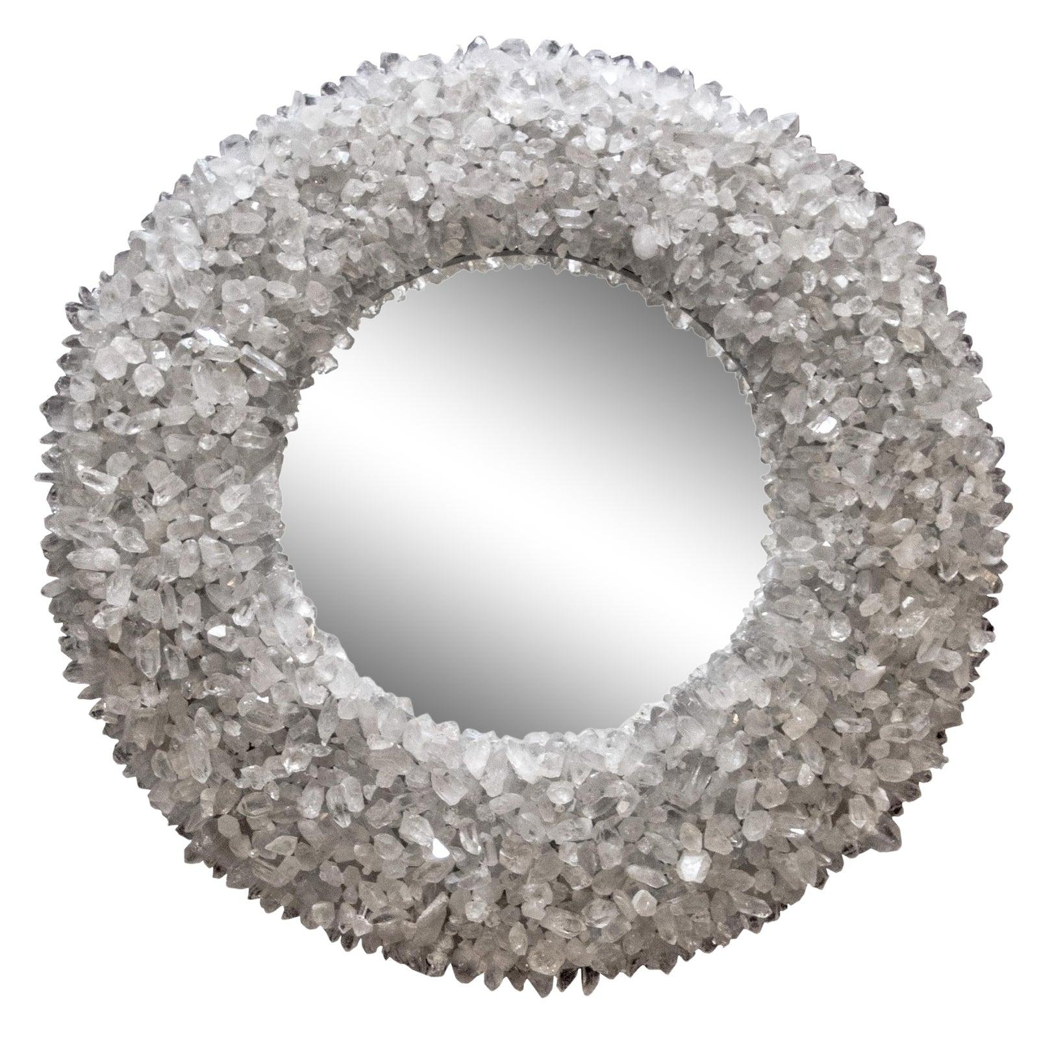

* CATEGORIES

Bedroom Mirrors

* MATERIALS

Bluetooth Mirrors

* SHAPE

Circle

* BRAND

Citybuilding